**Part C**

The figures can be recreated by executing the code PartC.m in matlab. Which solves the equations using VPAsolve, the steady state regimes were calculated by using the previous value of X and Z, and the unsteady states were found by bounding the Z and X search space, where Z was arbitrarily bounded to successfully evaluate vpasolve, and X was bounded based on the X values two saddle node points from the steady state evaluations over the appropriate S space.

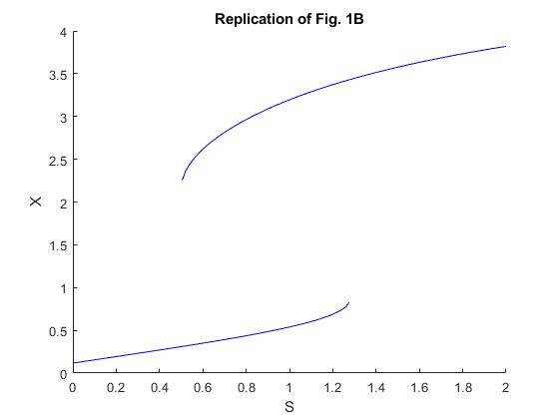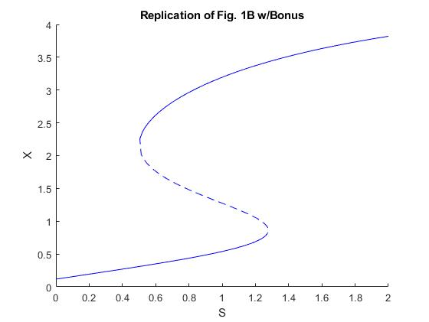

**Part D**

The figures can be recreated by executing the code PartD.m in matlab.

This uses the given mode parameters in the supplements, each system is solved by evaluating the set of ODEs with ODE 45 with the corresponding S, each of which is given in its own function. The initial state of the system is X=0, Y=0, Z=0

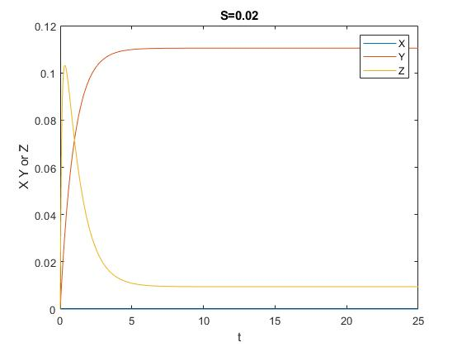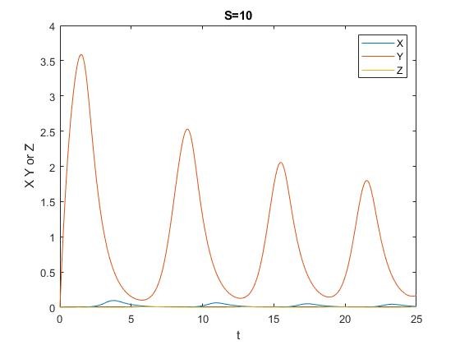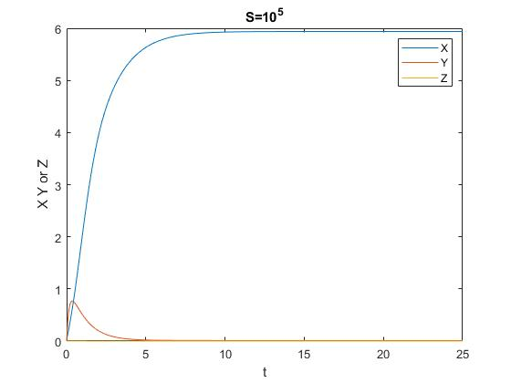

The time behavior of these three plots with different S values agrees at least qualitatively with the behavior shown in Figure 2. Where at low S there is low X in the middle range there are oscillations and above the saddle node bifurcation high constant X concentration for long time.

**Part E**

The figures can be recreated by executing the code ParE.m in matlab. Where the steady state values for a given S were calculated using vpasolve and then used to determine the time domain behavior of three cells with varying initial conditions from that steady state when S is now set to 100. The time domain behavior was calculated using ODE45 and the system of ODES in the included function.

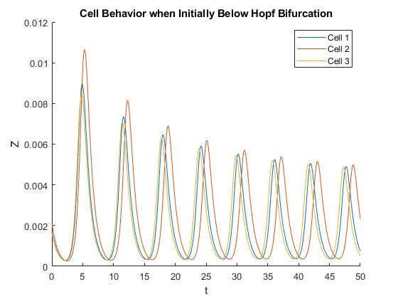

The oscillations when switching from an S below the Hopf bifurcation (S read off Fig 3) to S=100, the oscillations are incoherent. The three cells oscillate slightly out of phase with one another and this is maginified over time.

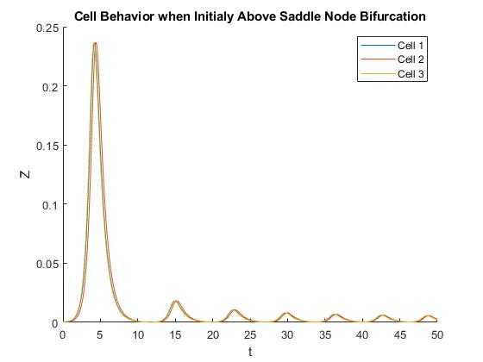

When switching from an S value above the Saddle node Bifurcation to S=100, the three cells all oscillate with very similar behavior, in magnitude and period. Their behavior is also not phase shifted from one another; therefore, the oscillations are coherent.

Based on the explanation in the paper this difference in behavior as a result of increasing or decreasing S to the same value are the result of limiting behavior and trajectory toward the oscillating regime. In the case of decreasing S the initial value for expression is far from the attraction spiral so they settle into the oscillations with the same phase from the beginning allowing for coherent behavior. On the other hand, increasing S from below the Hopf bifurcation leads to instabilities because attracting spiral states shift to unstable behavior, and this means that variation in the exact initial state of the species leads different phase behavior and therefore incoherence. The plotted data in this problem agree with their discussion where slight variation initially leads to incoherence when increasing S across the Hopf bifurcation and coherence when decreasing from above the saddle node bifurcation

**Part F**

Given that decreasing the value of S in the system I part D was able to achieve coherent oscillations, I would expect decreasing S from 105 to 100 to also lead to a coherent behavior. I believe the authors statement about achieving coherent behavior with the given the parameter values we used when decreasing S from 105 to 100.